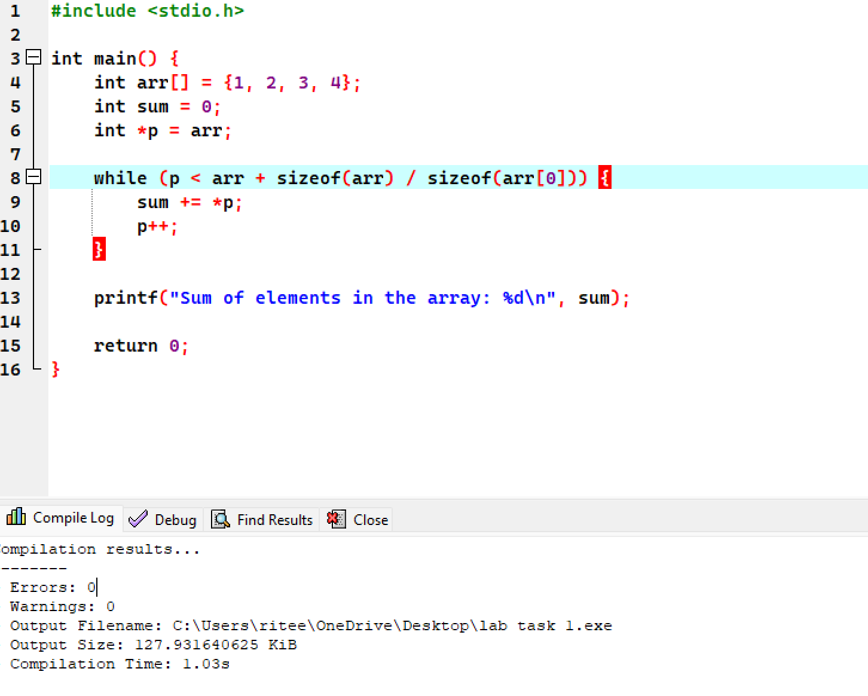

1)



2)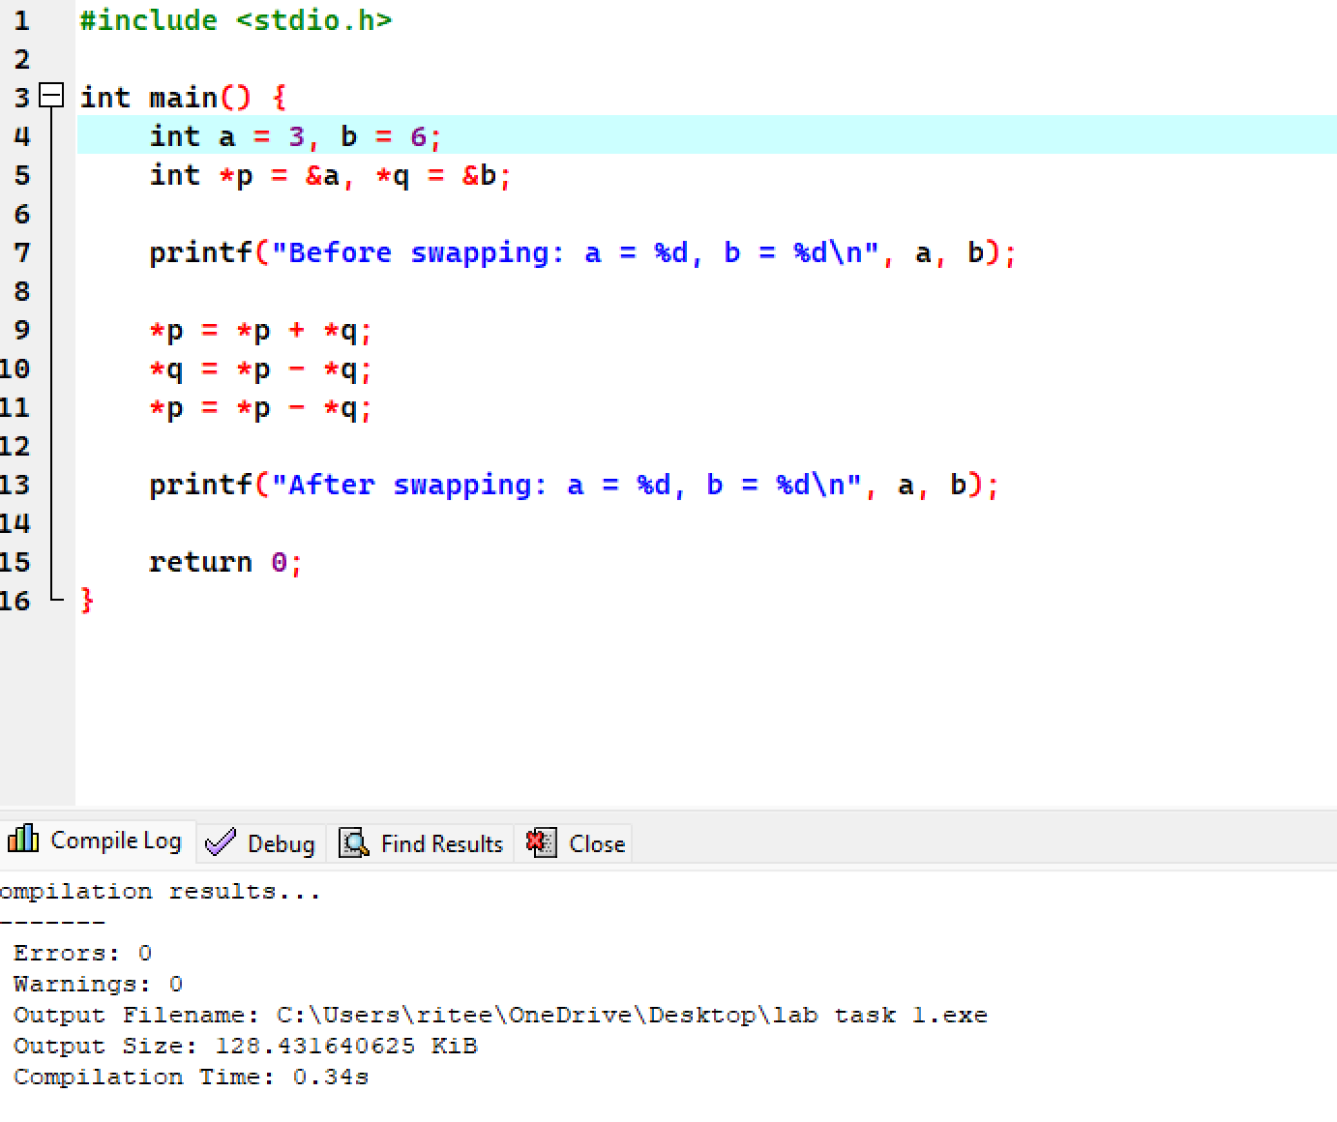

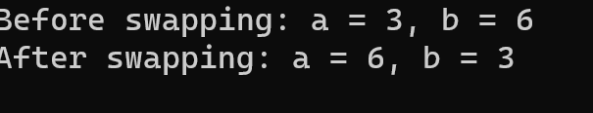

3)#include <stdio.h>

void reverseString(char \*str) {

char \*start = str;

char \*end = str;

char temp;

while (\*end != '\0') {

end++;

}

end--;

while (start < end) {

temp = \*start;

\*start = \*end;

\*end = temp;

start++;

end--;

}

}

int main() {

char str[100];

printf("Enter a string: ");

fgets(str, 100, stdin); // Use fgets for safer input

reverseString(str);

printf("Reversed string: %s", str);

return 0;

}

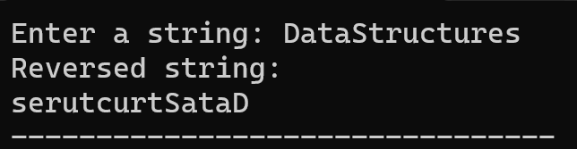

4)#include <stdio.h>

int calculatePower(int base, int exponent) {

int result = 1;

for (int i = 0; i < exponent; i++) {

result \*= base;

}

return result;

}

int main() {

int base, exponent;

int (\*powerFunction)(int, int) = calculatePower;

printf("Enter the base: ");

scanf("%d", &base);

printf("Enter the exponent: ");

scanf("%d", &exponent);

int result = powerFunction(base, exponent);

printf("%d to the power of %d is %d\n", base, exponent, result);

return 0;

}

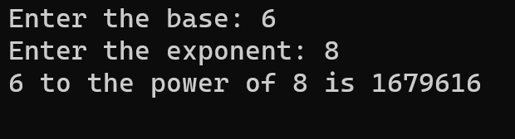

5)#include <stdio.h>

#include <stdlib.h>

int main() {

int rows, cols;

printf("Enter the number of rows: ");

scanf("%d", &rows);

printf("Enter the number of columns: ");

scanf("%d", &cols);

int \*\*arr = (int \*\*)malloc(rows \* sizeof(int \*));

for (int i = 0; i < rows; i++) {

arr[i] = (int \*)malloc(cols \* sizeof(int));

}

for (int i = 0; i < rows; i++) {

for (int j = 0; j < cols; j++) {

printf("Enter value for arr[%d][%d]: ", i, j);

scanf("%d", &arr[i][j]);

}

}

printf("\nThe 2D array is:\n");

for (int i = 0; i < rows; i++) {

for (int j = 0; j < cols; j++) {

printf("%d ", arr[i][j]);

}

printf("\n");

}

for (int i = 0; i < rows; i++) {

free(arr[i]);

}

free(arr);

return 0;

}

